**Recursive Sorting algorithms**

1. Divide and conquer methods

* **MergeSort**: Mergesort is a divide and conquer algorithm which is divided in two parts, **divide** and **combine**.

It uses recursive calls to itself, therefore the complexity is calculated with recursive equations.

$W_{MS}\left(N\right)≤{2·W}_{MS}\left(\frac{N}{2}\right)+N-1;$ $B_{MS}\left(N\right)≥2·B_{MS}\left(\frac{N}{2}\right)+\frac{N}{2}$

$W_{MS}\left(N\right)≤N·\log\left(N\right)+O\left(N\right)$ $B_{MS}\left(N\right)≥\frac{1}{2}·N·log\left(N\right)$

$$A_{MS}\left(N\right)=Θ(N·log⁡(N))$$

The runtime of the algorithm is good, but it uses dynamic memory and being recursive makes it less efficient regarding the stack.

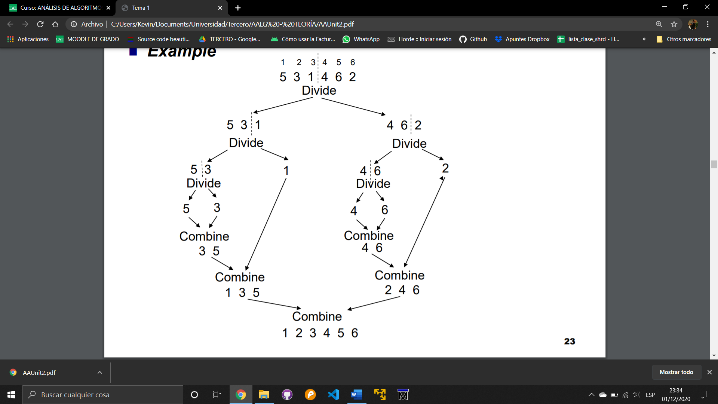

* **Quicksort**: Quicksort is also a divide and conquer algorithm which is divided in two parts, **divide** and **combine**.

*Divide* takes an element of the array and then the array is sorted based in that element.

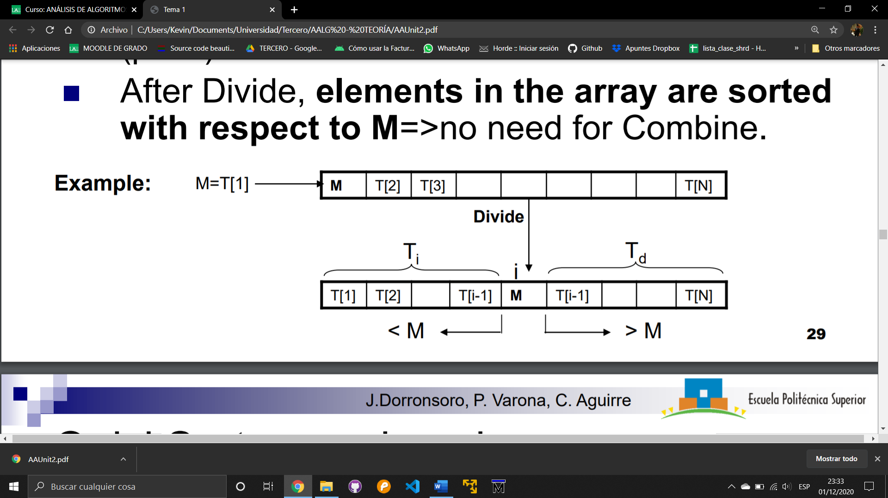

The **pivot** (M) can be selected in a lot of ways, not just the first element.

$$W_{QS}\left(N\right)≤\frac{N^{2}}{2}-\frac{N}{2}$$

$$A_{QS}\left(N\right)= 2·N·log \left(N\right)+O(N)$$